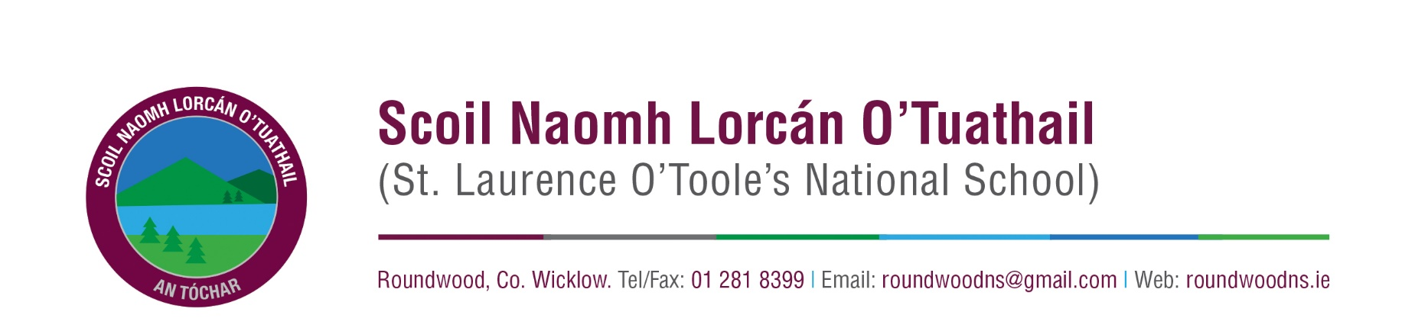
Healthy Lunch Policy

Introduction
The Board of Management of St Laurence O’Toole’s National School understand that children need to healthily to achieve their full potential. Healthy eating provides the building blocks for lifelong health and wellbeing. As part of the Social, Personal and Health Education (SPHE) programme, we encourage children to become more aware of the need for healthy food in their lunch boxes. This Healthy Lunch Policy was created through a process of consultation between teachers, pupils, parents and the Board of Management. Surveys were conducted and the results were collated to form the final policy and ensure that there is a common understanding between all members of the school community about what constitutes healthy eating.

Rationale
For children to grow and develop they need an adequate intake of energy and nutrients. Eating a nourishing breakfast and a healthy school lunch allows children to reach their educational potential. Research indicates a strong link between diet and performance - low sugar intake promotes concentration, lessens hyperactivity, protects teeth and lessens the risk of diabetes. A low salt intake reduces the risk of heart disease in later life.

As part of the Social, Personal and Health Education (SPHE) Programme, at St. Laurence O’Toole’s National School we encourage children to become more aware of the need for healthy food in their lunch boxes.

Aims
- To encourage the nutritional and overall wellbeing of all pupils in the school
- To support pupils to develop lifelong healthy eating practices and a positive approach towards food
- To encourage pupils to make wise choices about food and nutrition
- To raise levels of concentration within class due to consumption of healthy food
- To recognise the dietary needs of all pupils and aim to ensure that all pupils’ individual and cultural needs are met

Whole School Approach to Healthy Eating

Eating Lunches
Children have two breaks during the school day. The first break is a 10 minute break where children are encouraged to eat a snack and have a drink. This is followed by yard time for a further 10 minutes. At 12.50pm, children eat the remainder of their lunches and go back out to yard for 30 minutes. Children eat their lunches at their desks in their classrooms and encouraged to practice good hand-washing practices by their teachers, before eating.

Promote Healthy Eating at home and at school
St Laurence O’Toole’s N.S. provides a physical and social environment that encourages healthy eating. We strive to ensure that lessons learned in the classroom are transferred into school life and that healthy eating messages are consistent throughout the school. Lunch is an important meal for school-going children. It should provide one third of their recommended daily allowance of nutrients without being high in fat, sugar or salt. However, we cannot stress enough the importance of the children getting a good breakfast each morning before they come to school. Breakfast/ lunch should also provide dietary fiber (roughage).

The traditional packed lunch of milk and sandwiches is under attack from a range of convenience foods like crisps, sweets, biscuits, chocolate and soft drinks. Parents and teachers are concerned about this trend, but some find it difficult to come up with popular healthy alternatives. We ask you to encourage a healthy lunch right from the start.

Healthy Lunch Options
In St Laurence O’Toole’s N.S. we have devised the following healthy lunch options to help guide parents in providing quick, appetising and nutritious lunches for children every day.
Bread & Alternatives  Bread or rolls, preferably wholemeal  Wholemeal Scones  Bread sticks  Crackers  Pitta bread  Wraps  Rice cakes  Rice  Pasta  Potato Salad | Savouries  Lean Meat  Chicken/Turkey  Tinned Fish e.g. tuna/sardines  Cheese  Vegetarian Sausage  Chickpeas  Quiche  Beans  Houmous  Granola bars/flapjacks/healthy cereal bars  Yogurts (no nuts/chocolate)
Fruit & Vegetables  All Fruit & Berries  Seedless grapes cut  All vegetables  Seeds (Sunflower, pumpkin, sesame etc.) | Drinks  Water  Flavoured water  Milk

Snacks known to be high in sugar, saturated fat, salt, additives and preservatives, including the following, are not allowed to be brought to school:

Crisps (including crisp-style snacks)
- Fizzy drinks and sports drinks
- Nut products, including nutella
- Sweets, Chewing gum, fruit winders
- Chocolate biscuits/bars
- Chocolate spread
- Cereal bars – with nuts/chocolate/sugary coatings
- Chocolate yogurts
- Pastries / cakes
- Popcorn

Water
Water is a crucial element in children’s diets and in St Laurence O’ Toole’s N.S. we understand the importance for children to be hydrated in order to learn efficiently. For this reason, the following procedures are in place:
- Children are allowed to access their water bottles if they are thirsty throughout the school day.
- Bottles are to be kept in school bags or in a designated area of the classroom (teacher discretion)

Milk
- Growing children should get approximately one pint of milk a day, or its equivalent as cheese, yoghurt or milk pudding. This ensures that they get enough calcium, which is essential for healthy bones and teeth. If a child does not drink a glass of milk at lunch, encourage her/him to have a carton of yoghurt or a small helping of cheese instead.

Allergies
St. Laurence O’Toole’s National School is a “Nut Product Free Zone” due to allergies in the school. It is important that no nut products are brought into the school for health and safety reasons. It may be necessary on a case by case basis to ban certain food products from specific classes when allergies are present among pupils in a class. Parents/guardians will be informed of any allergies and banned food items.
All parents/guardians are asked to update the school as soon as possible on medical conditions and allergies as they arise to ensure that the school environment is safe for all pupils at all times, specifically in relation to food items.

Green Flag School
We are a Green School and part of this is to keep our waste consumption down. With this in mind, children are also asked to:
- take home (in lunchbox) all uneaten food, silver paper, wrappings, containers and cartons
- not bring in cans and glass – for safety reasons

Food Dudes
As a school we participate in the Food Dudes programme which promotes healthy eating of fruit and vegetables. We encourage children to try new fruit and vegetables and to develop healthy eating habits through involvement in this programme.

Roles and Responsibilities
- The Healthy Lunch Policy is promoted by teachers in their classes and displayed in every classroom.
- Children are reminded of our policy during assemblies throughout the year.
- Parents are informed through newsletters of the need to ensure lunches are healthy and adhere to school policy.
- This policy is displayed on our school website and given out in the junior infant welcome pack.
- All special dietary requirements will be respected inclusive of dietary needs and cultural dietary habits. Children with allergies will be treated with care and they will be made know to the teaching staff following our school procedures for medical conditions.
- Teachers will enforce the Healthy Lunch Policy in their classrooms.
- Teachers have the right to confiscate fizzy drinks and any other foods deemed inappropriate.
- The Board of Management will ensure that the policy is reviewed and updated when necessary.

Monitoring and Review

This policy will be reviewed regularly and as the need arises.

This policy was ratified by the Board of Management on 12th May 2020.
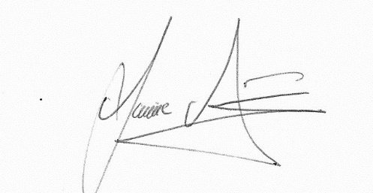

Chairperson of the BOM: Jamie Fitzmaurice

